**The Museum of Entrepreneurs, Patrons and Philanthropists**

<https://muzeydela.ru/?ysclid=ma55hrzdeq403836032>

**The hall of entrepreneurs, patrons and benefactors of the 19th - early 20th century**

1. **Study the gallery of portraits of famous entrepreneurs and find an advertising image of Ivan Kondrashev. Answer the questions:**

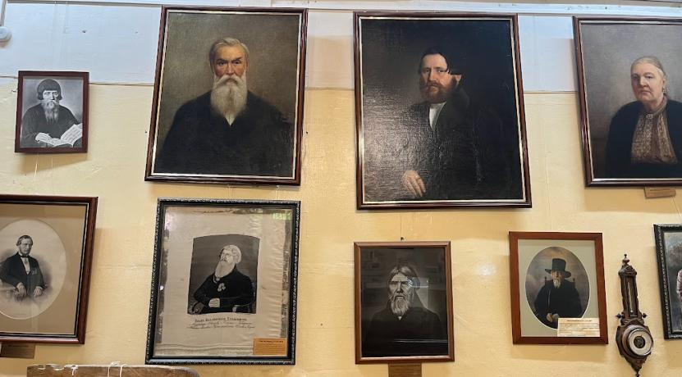

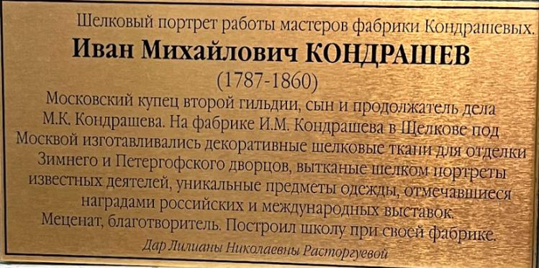

1. What were Kondrashev’s business and charitable activities?
2. What material is the exhibit made of?
3. Why can the exhibit be called an advertising image?

___________________________________________________________________________________________________________________________________________________________________________________________________________________________________________________________________________________________________________________________________________________________________________

1. **Study the exhibit devoted to the business of the Kashtanovs and answer the questions:**

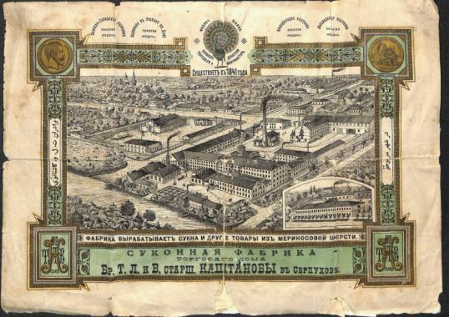

1. When was the Kashtanovs’ factory founded?
2. Where was it situated? What symbol of the place can be found on the trade mark?
3. How many Kashtanov brothers were there in the business?
4. The family business followed the order of Peter I: *“Garrison regiments of all provinces should have their uniforms, caftans, doublets, and trousers made from Moscow cloth, but not from imported overseas cloth……”* Explain how the entrepreneurs made a contribution to the process of import substitution.

_____________________________________________________________________________________________________________________________________________________________________________________________________________________________________________________________________________________________________________________________________________________________________________________________________________________________________________________________________________________________________

1. **Match the letters to the numbers (there are two extra pictures):**
2. 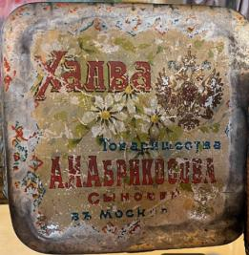 2. 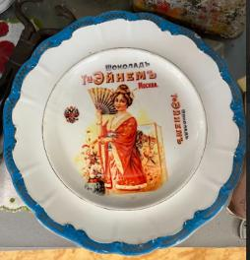
3. 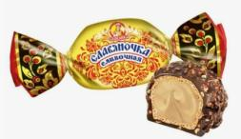 b) 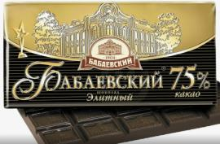

c) 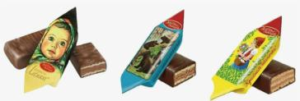 d) 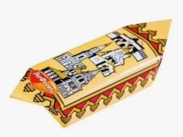

_______________________________________________________

**4. In the photo below you can see a famous representative of the Alekseev dynasty. Read the comment and write his pseudonym:**

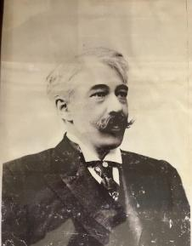

Among the Alekseevs was the famous theatre reformer, who began his career at his father's factory, where they made gold and silver thread. He took the pseudonym ………………………….. in 1885 at the age of 22 in order not to "disgrace his family" with too strong a passion for the theatre.

_______________________________________________________

**The hall of joint-stock business, financial and stock markets of Russia of the 19th - early 20th century**

**5. The von Meck dynasty was engaged in the construction and development of Russian railways. Why was it important for the country?**

**_____________________________________________________________________________________________________________________________________________________________________________________________________________________________________________________________________________________________________________**

**6. Study «Moscow city plan with suburbs», find the railway surrounding the city. What modern transport structure corresponds to this railway?** (choose the picture) **What is its modern name?** (choose the option)

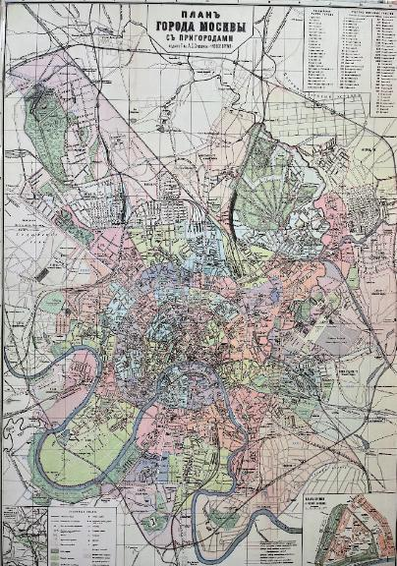

1. 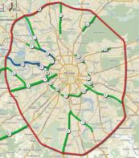 2. 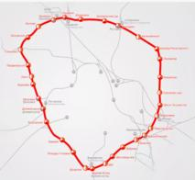 3. 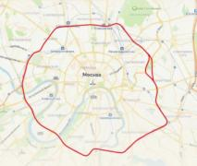

A) Third Ring Road (ТТК)

B) Moscow Ring Road (МКАД)

C) Moscow Central Circle (МЦК)

____________________________________________________________________________________________________________________________________________________________________________________________________________________________________________________

**The hall of upbringing and education of children in the 19th - early 20th century**

**7. Study the candy wrappers. What educational value do they have? How can they be used at the lessons? What school subjects do they represent?**

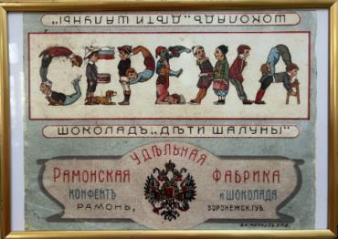 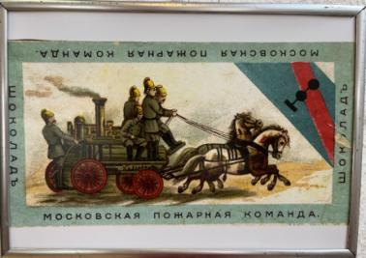

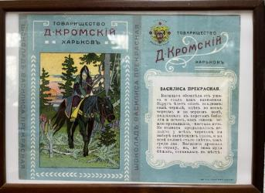 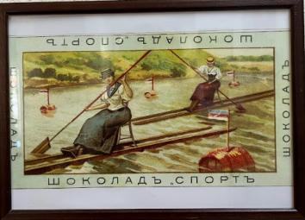

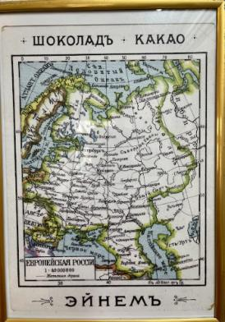

____________________________________________________________________________________________________________________________________________________________________________________________________________________________________________________________________________________________________________________________________________________________________________________________________________________________________________________________________________________________________________________________________________

**8. Read the rules for the students and say if the statements are TRUE (T) or FALSE (F).**

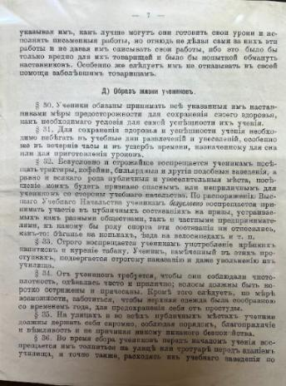

1. Students could not copy assignments from their friends or let them copy their work. __________
2. They were not allowed to help their ill groupmates.__________
3. On school days, students could only have fun in the evenings. ________
4. Students were forbidden to visit coffee shops, taverns, billiard rooms. ____
5. Students could take part in various competitions in order to receive prizes. _________
6. Students could be expelled from the school for smoking or drinking alcohol. _________
7. Students were not allowed to have long hair. ______
8. Students were supposed to behave modestly and politely only at school.________
9. Before classes, students could gather on the sidewalk in front of the school and chat. _______

**The hall of entrepreneurs, patrons and benefactors of the 19th - early 20th century**

1. **Study the information about the Bashkirovs in the photo, then read and complete the text with the given words and word combinations:**

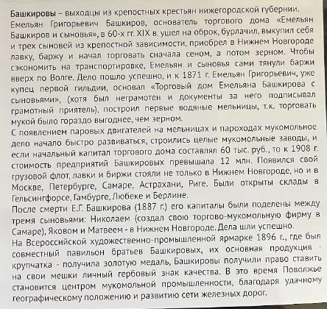

guild hay and then grain stamp profitable

fleet engines transportation serfs

geographical stock had exceeded

**THE BASHKIROVS**

The Bashkirovs originated from the **1)** ………….. from Nizhnii Novgorod province. The founder of the trading house “Iemelian Bashkirov and Sons” was Iemelian Grigorievich Bashkirov. In the 60s of the 19th century he bought himself and his three sons from serfdom, purchased a shop and a barge in Nizhnii Novgorod and began trading, first in **2)** ……………. To save on **3)** ……………….., Iemelian and his sons pulled barges up the Volga themselves. The business went well, and by 1871 Iemelian Grigorievich, being a merchant of the first **4)** ………….., had founded the trading house. He was illiterate, so all the documents were singed by a competent friend. The Bashkirovs built their first watermills because it was much more **5)** ……………… to trade flour than grain.

Due to the advent of steam **6)** ……………. in mills and steamships, the milling business began to develop rapidly. Big flour mills were built. By 1908 the value of Bashkirov enterprises **7)** ……………. 12 million rubles (the initial capital of the trading house was 60 thousand rubles). A cargo **8)** …………… appeared, Bashkirov’s shops and **9)** …………. exchanges were situated not only in Nizhny Novgorod, but also in Moscow, St. Petersburg, Samara, Astrakhan, Riga. Warehouses were opened in Helsingfors (today’s Helsinki), Hamburg, Lubeck, Berlin.

At the All-Russian Art and Industrial Fair in 1896, where Bashkirov brothers had a pavilion, their main product – grain – received a gold medal. The Bashkirovs were given the right to put a personal **10)** …………. on their bags. At this time, the Volga region became the centre of milling industry, due to its **11)** ……………. location and the development of the railway network.

**Answer the questions:**

1. What was the social origin of the Bashkirovs?
2. What factors influenced the development of the Bashkirovs’ business?
3. What did the membership in the first guild mean for the merchants?

________________________________________________________________________________________________________________________________________________________________________________________________________________________________________________________________________________________________________________________________________________________________________________________________________

1. **Give a brief presentation of the exhibit (use the information from the text and the photo):**



